

# Instagram User Analytics

**CHIRAG  TAK                       2105451**

**NAYAN  KUMAR                   2105473**

**SUNNY  SRIVASTAVA          2105505**

**RAJASHREE  DEB                2105564**

**OM  SINGH                             2105634**

**UNDER THE GUIDANCE OF**

**Dr. SOUMYA RANJAN NAYAK**

**UNDER THE GUIDANCE OF**

**Dr. SOUMYA RANJAN NAYAK**



**Project Agenda:**

* Project Description: Instagram is one of the most popular social media applications today. People using Instagram professionally are using it for promoting their business, building a portfolio, blogging, and creating various kinds of content. As Instagram is a popular application used by millions of people with different niches, Instagram keeps changing to make itself better for content creators and users. But as this keeps changing, it affects the reach of our posts which affects us in the long run. So if content creator wants to do well on Instagram in the long run, they have to look at the data of their Instagram reach. That is where the use of Data Science in social media comes in.
* I have been researching Instagram reach for a long time. Every time I post on my Instagram account, I collect data about how successful the post is after a week. This helps to understand how the Instagram algorithm works. If you want to analyze the reach of your Instagram account, you have to collect your data manually because there are some APIs, but they don’t work well. Therefore, it is better to collect your Instagram data manually.
* If you want to learn how to analyze Instagram reach using Python, you can use the data I collected from my Instagram account. You can download the dataset I used to analyze Instagram reach [here](https://drive.google.com/file/d/1pNXMJgwyhLlNHqlThFxa675GZ-gP1vm3/view?usp=sharing).

# Task 1: Analyzing Instagram Reach



Insights:

- Let’s start with analyzing the reach of my Instagram posts.

- I will first have a look at the distribution of impressions I have received from home.



Task 2: **Impressions Analysis**

Insights: Impressions from different sources like home, hashtags, and explore sections are crucial for understanding post reach.

Hashtags play a significant role in expanding post visibility to a broader audience.

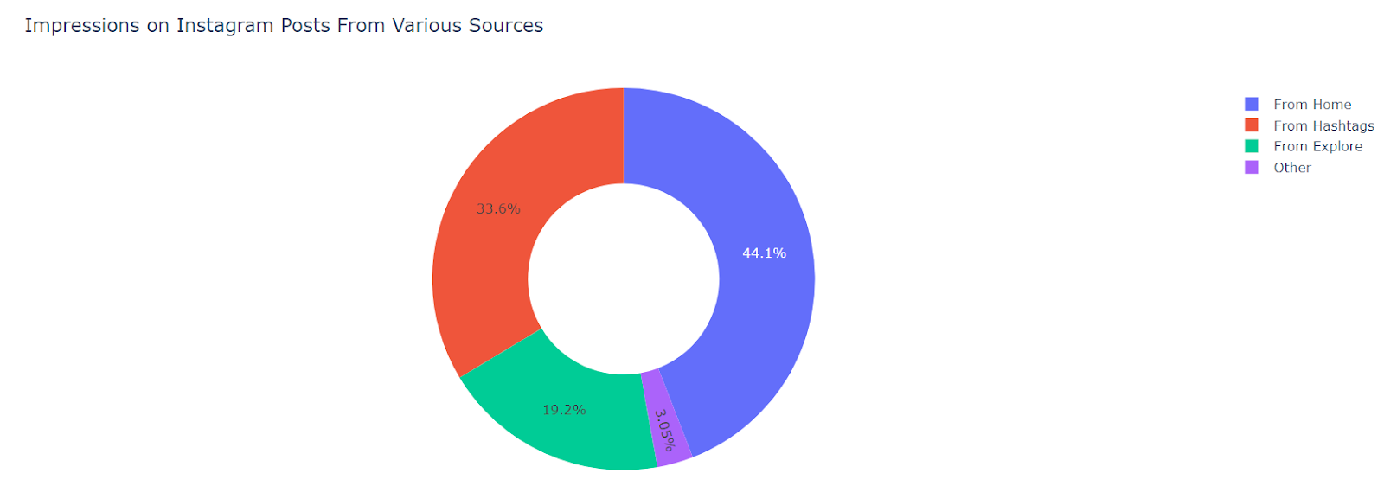



**Task 3: Relationship Analysis**

##### Insights: Relationships between likes, comments, shares, and impressions reveal valuable insights into engagement patterns. Notable findings include a positive correlation between likes and impressions, indicating the impact of likes on post reach.

#### Task 4: Conversion Rate Analysis.



Insights: Conversion rate, calculated as (Follows/Profile Visits) * 100, showcases the effectiveness of posts in attracting new followers.

A high conversion rate signifies engaging content that resonates with the audience.



### Task 5: Determine the day of the week with the most user registrations

##### Output:

Insights: The distribution of user registrations by day of the week has been provided.

This information can guide the scheduling of ad campaigns, focusing efforts on days when new user registrations are higher.



Task 6: **HASHTAG ANALYSIS**

Insights: - Hashtags are tools we use to categorize our posts on Instagram so that we can reach more people based on the kind of content we are creating.

- Looking at hashtag impressions shows that not all posts can be reached using hashtags, but many new users can be reached from hashtags.

- Now let’s have a look at the distribution of impressions I have received from the explore section of Instagram.

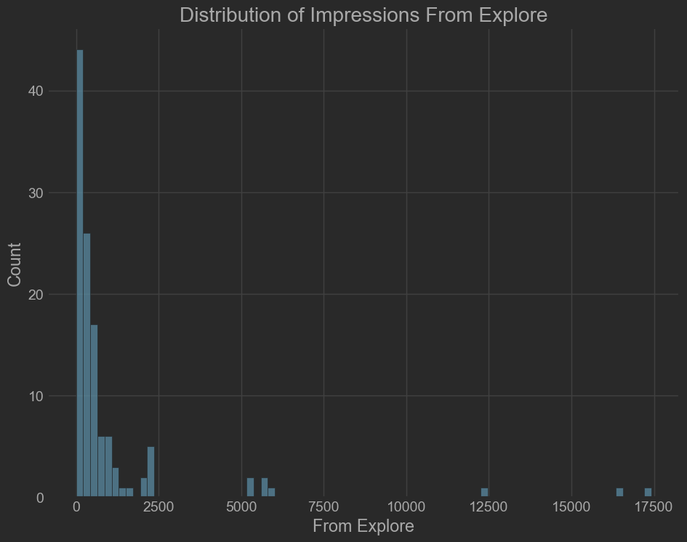



### Task 7: Identify users (bots) who have liked every photo on the site

##### Output:

Insights: A list of users who have liked every single photo on the

site has been generated.

The fake accounts or bots can be removed to enhance user experience and check the actual performance of the business.



Result:

* Acquired fundamental data analysis skills using Python, leveraging libraries like pandas, matplotlib and many more. Utilized Python to extract insights from Instagram data, focusing on user engagement across desktop and mobile apps. Aimed to derive business insights for marketing, product, and development teams.



# THANK YOU